Name: Ryan Peters Collaborators: Solo, am only just getting over a flue bug

R Lab 2: Introduction to data

Please answer all the Exercises and the questions from the “On Your Own” section. If you use any graphs or charts to justify your answer, please include them.

Exercise 1: How many cases are there in this data set? How many variables? For each variable, identify its data type (e.g. categorical, discrete).

There are 20,000 cases

Exercise 2: Create a numerical summary for height and age, and compute the interquartile range for each. Compute the relative frequency distribution for gender and exerany. How many males are in the sample? What proportion of the sample reports being in excellent health?

summary for height:
Min. 1st Qu. Median Mean 3rd Qu. Max.
48.00 64.00 67.00 67.18 70.00 93.00

height iqr = 6 (assumed inches)

summary for age:
Min. 1st Qu. Median Mean 3rd Qu. Max.
18.00 31.00 43.00 45.07 57.00 99.00

age iqr = 26 (assumed years)

Counts for people saying yes to exerany, by gender:
0 1
m 2149 7420
f 2937 7494

Relative frequency of people saying yes to exerany, by gender:
0 1
m 0.10745 0.37100
f 0.14685 0.37470

There are 9569 males in the study
4657 people report being in excellent health.

Exercise 3: What does the mosaic plot reveal about smoking habits and gender?

Even though males are a slight minority in this sample, there are significantly more of them who had smoked 100 cigarettes.

Exercise 4: Create a new object called under23_and_smoke that contains all observations of respondents under the age of 23 that have smoked 100 cigarettes in their lifetime. Write the command you used to create the new object as the answer to this exercise.

under23_and_smoke <- subset(cdc, cdc$age < 23 & cdc$smoke100==1)

Exercise 5: What does this box plot show? Pick another categorical variable from the data set and see how it relates to BMI. List the variable you chose, why you might think it would have a relationship to BMI, and indicate what the figure seems to suggest.

I’ve chosen to use gender, as it already seems apparent from the other interpretations we made on the dataset’s observations that men and women have seemingly distinct manifestations of the data.

According to the figure (see figure 1) it appears that men tend to have a higher BMI than women, which actually corroborates nicely with the other observed trends regarding exercise and smoking.

On Your Own:
1) Make a scatterplot of weight versus desired weight. Describe the relationship between these two variables.
See Figure 2 for the requested scatter plot
There appears to be a significant trend in the sample where people say their actual weight and desired weight are the same. So, I subset that group, and found that they are just over 28% of the sample population. I also created a subset of only those that say their actual weight and desired weight are different, Figure 3. From just that subset I can see that the magnitude of the desired weight seems to change inversely to the individuals weight with respect to what appears to be approximately 180 to 200 lbs.

2) Let’s consider a new variable: the difference between desired weight (wtdesire) and current weight (weight). Create this new variable by subtracting the two columns in the data frame and assigning them to a new object called wdiff.
It appears I’ve already done this in order to create the subsets mentioned in my answer to question 1.
Here’s the command:
wdiff <- cdc$weight – cdc$wtdesire

3) What type of data is wdiff? If an observation wdiff is 0, what does this mean about the person’s weight and desired weight. What if wdiff is positive or negative?
wdiff is a vector of discrete values. Well, assuming that the expectation is to assign wdiff by subtracting the desired weight from the actual weight, a positive or negative sign indicates the individuals intention to either gain or lose weight, respectively.

4) Describe the distribution of wdiff in terms of its center, shape, and spread, including any plots you use. What does this tell us about how people feel about their current weight?
See Figures 3, 4, and 5. As you can see by the various plots, the desired and actual weights of the sample have very similar curves, with the genders each displaying a distinct trend in how there desired weights differ from their actual weights. It appears that women in general wish to actually weigh more, while men appear to generally want to weigh less.
This surprises me considering the fact that you typically hear of men aspiring to be larger, more physical and more alpha in their stature, while women seem to be constantly trying to fit into old clothes from when they were younger.
5) Using numerical summaries and a side-by-side box plot, determine if men tend to view their weight differently than women.
Again, I appear to have answered this in the previous question (question 4), but for a TL;DR, yes. Men appear to want to weigh less than they do, while women appear to want to weigh more.
6) Now it’s time to get creative. Find the mean and standard deviation of weight and determine what proportion of the weights are within one standard deviation of the mean.
Calculated values for cdc$weight:
variance = 1606.484
mean = 169.683
median = 165
standard deviation = 40.08097
Summary for the subset of the cdc data frame where only cases that have wheights that satisfy:
mean-std_dev < x < mean+std_dev
the number of cases in this subset, divided by the number of cases in the cdc dataframe is: 0.7076
That’s 70.1%
Figure 1 BMI vs. Gender
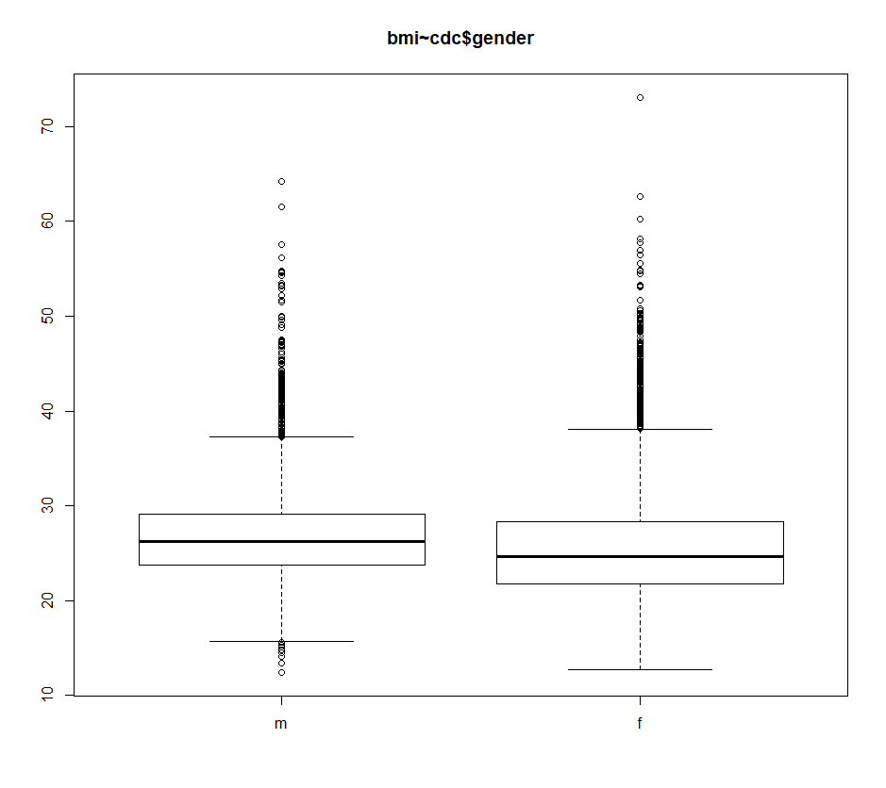

Figure 2 Desired Weight vs Weight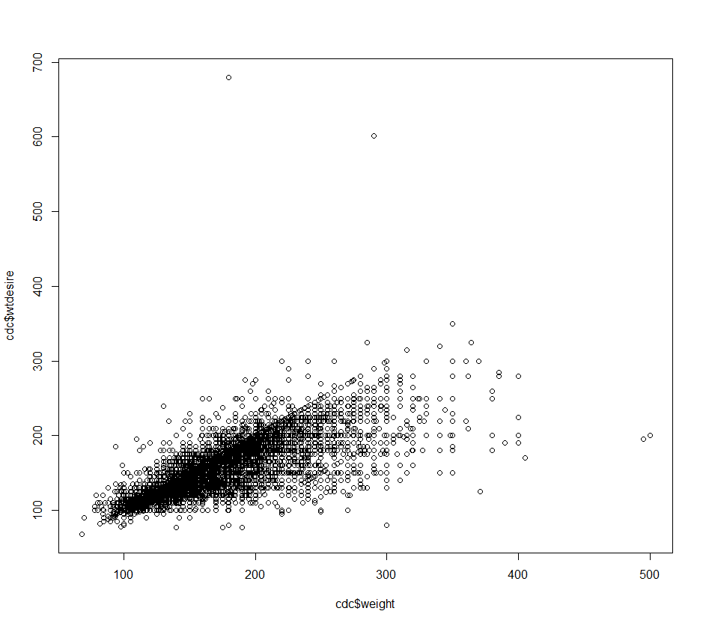

Figure 3 Subset of where only weight!=wtdesire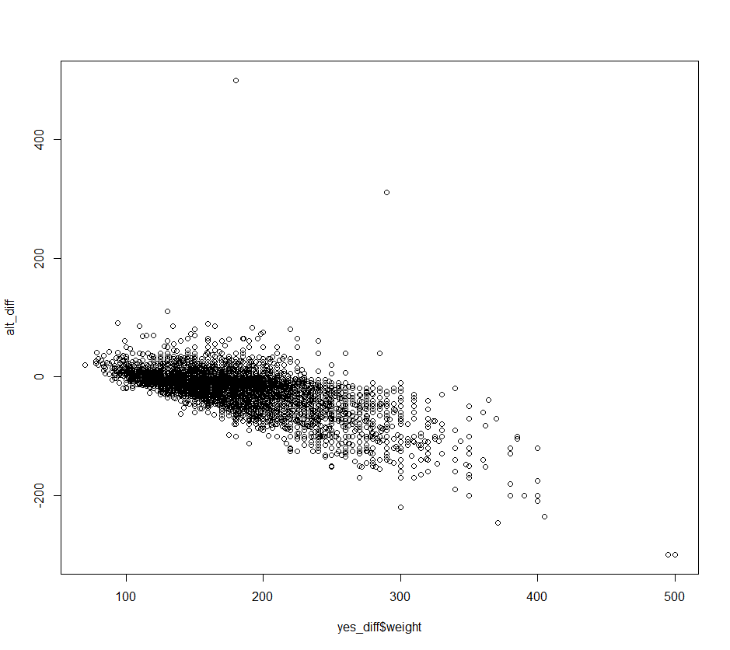

Figure 4 Female line chart showing actual and desired weights
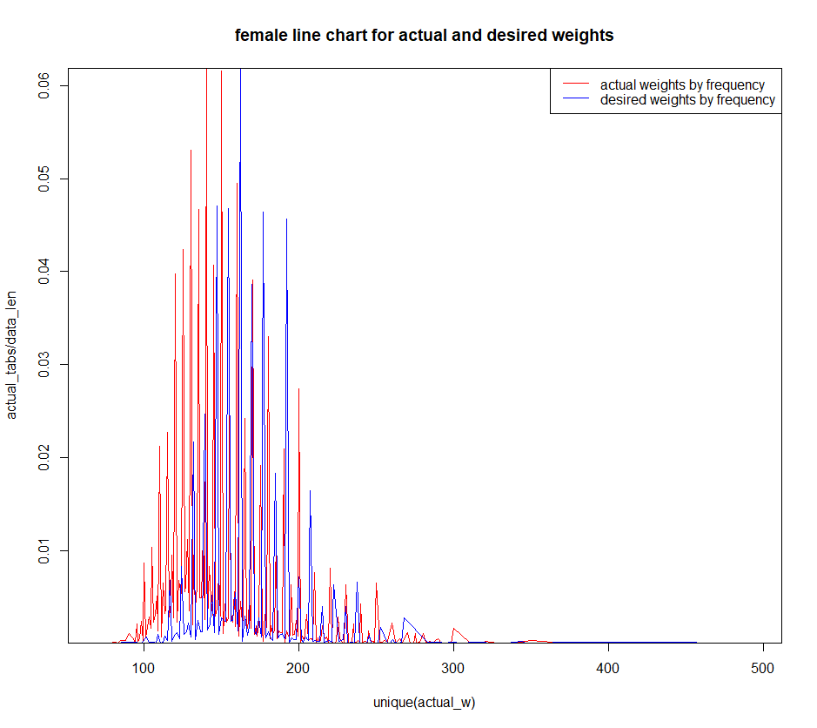

Figure 5 Male line chart showing actual and desired weights
